**Food Studies 8 Name: _______________**

**Block: ____ Unit #: ____**

**MCj02159430000[1]Eggs**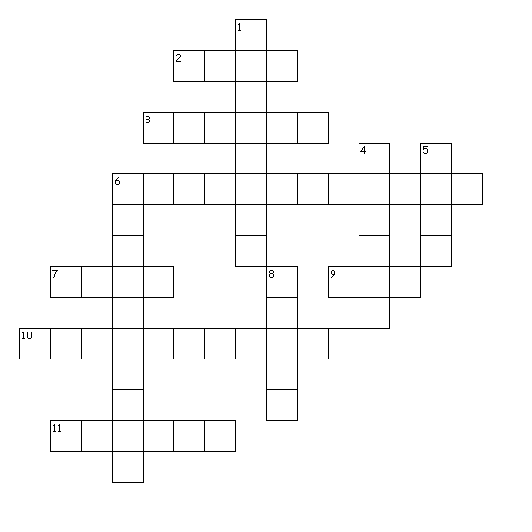

**Across**

2. Eggs may be eaten as an alternate to _ _ _ _

3. Eggs are most commonly available in this grade **G R A D E A**

6. A place to keep eggs in at home

7. The mineral found in eggs needed for healthy blood

9. Eggs should be cooked at _ _ _ to moderate temperatures

10. This type of fat is found in egg yolk and can block arteries

11. Egg should be simmered not **­B O I L E D**

**Down**

1. The process used to grade eggs **C A N D L I N G**

4. It is best to keep eggs in a _ _ _ _ _ _ when storing

5. The centre of the egg; it contains most of the nutrient value found in eggs

6. This B vitamin is found in eggs

8. The eggs used in baking are usually sizes medium and _ _ _ _ _

June 2013